CLASS COPY-DO NOT WRITE OR TAKE THIS PAPER!

4th Six weeks CBA Science Study guide
- What is a spacewalk and what does an astronaut do with a tether?
- What is the sun made of?
- What are the characteristics of inner planets? Outer planets?
- Where are the two main asteroid belts located in our solar system?
- Explain and draw a model of the relationship between two objects with different gravitational forces. (Example:) How would this change if the mass of the objects were larger or smaller?
- If the distance between two objects increased, how would this effect the gravitational pull? What if the distance decreased?
- What is an un-manned spacecraft? What is a manned spacecraft?
- Name several things that are important for a manned spacecraft traveling through outer space to carry with them?
- Explain the movements of the sun, moon, and earth. Draw a diagram of these movements labeling the sun, moon, earth, rotation, and revolution.
- Define, draw, and color each word in the table on your paper.
- What two things are necessary to create an orbit? Hint: it goes straight and then causes the object to curve around and come back.
- What were some of the challenges scientist faced in order to launch the first rocket into outer space?
- List the things scientist learn from the lab on the ISS (international Space Station) as it orbits Earth.
- Name some important functions of the space suit that astronauts use to travel into outer space.
- Compare and contrast space telescopes vs. earth-bound telescopes.

9.
Name: ____________________________________ Date: _____________________ Block:________________
Word | Definition | Illustration
Inner planets

Outer planets

Comet

Meteor

Asteroid

Io

Europa

Callisto

Ganymede

12.
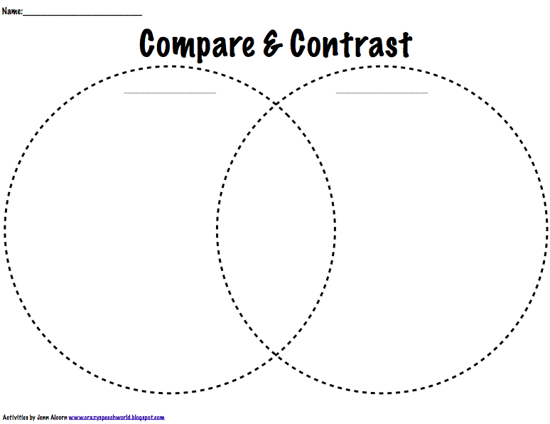

8.

